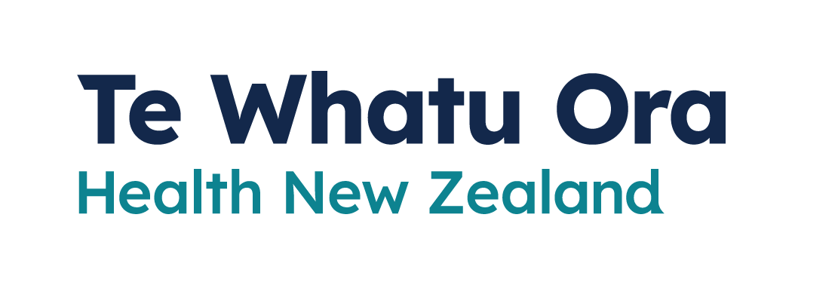
Testing
Adapted in 2023 by Accessible Formats Service,
Blind Low Vision NZ, Auckland
TN: There are two logos at the top of the page. On the left is: Te Kāwanatanga o Aotearoa New Zealand Government. On the right is: Te Whatu Ora
Health New Zealand.

Testing
Getting tested for COVID-19 is free.

When you should get a test
- If you are unwell
If you have cold, flu or COVID-19 symptoms, get a test as soon as you start to feel unwell. Doing a test and reporting the result means you can get the help you need as early as possible.
- If you are a Household Contact of someone with COVID-19
If you are a Household Contact of someone who has COVID-19, we recommend you do a RAT each day for 5 days.

If you have had COVID-19 before
If you have had COVID-19 before and get symptoms again, what you should do depends on how long it has been since your previous infection.
Count the days from when you tested positive or first had symptoms:
- 28 days or fewer since last infection
If you are at low risk of serious illness, you do not need to take another test. We recommend you stay at home until you are recovered.
If you have an underlying health condition or have COVID-19-like symptoms that are getting worse, get advice from a health practitioner or Healthline on 0800 358 5453.
- 29 days or more since last infection
You should take a rapid antigen test (RAT). If it is positive for COVID-19, it is recommended you isolate for at least 5 days.

Where to get a test
You are allowed to leave your home to get a COVID-19 test while you are isolating.

Access free RAT home testing kits
You can pick up free RATs for yourself and household members from COVID-19 testing centres and collection sites including some pharmacies. Find a collection centre near you:
To find a RAT collection site near you, go here: www.healthpoint.co.nz/covid-19

Get a test from your doctor
Your doctor may offer COVID-19 tests. Call them to find out and follow their advice.

If you need help to get RATs
If you live rurally, have a disability, are immunocompromised or experiencing some other difficulty getting RATs, you may be eligible for additional help, including delivery if necessary.
To find out if you are eligible, call 0800 222 478.

How to report your RAT results
Whether positive or negative, you should report the results of your RAT. Reporting the result means you can get the help you need as early as possible.
You will receive a text confirmation from either 2328 or 2648 with information about isolation and useful advice.

Report your results online
You can report a RAT result for yourself or someone else on your My Covid Record account. You will need the NHI number of the person.
To report your RAT result, go here: www.MyCovidRecord.nz

Report results over the phone
You can report a RAT result over the phone if you are having trouble using My Covid Record, or want to report someone else's RAT result and do not have their NHI.
Call: 0800 222 478

If you need support
- The COVID-19 disability helpline can provide help or information about vaccines, face mask exemptions, testing, managing COVID-19, and any other health concerns you may have.
Call 0800 11 12 13 for free. If you are unable to call, you can text 8988.
- The COVID-19 welfare phone line can help if you are self-isolating and need food or other essential items. Call 0800 512 337.
- You can also call Healthline for free for advice on
0800 358 5453.
End of Testing

