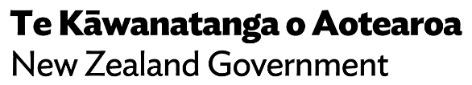
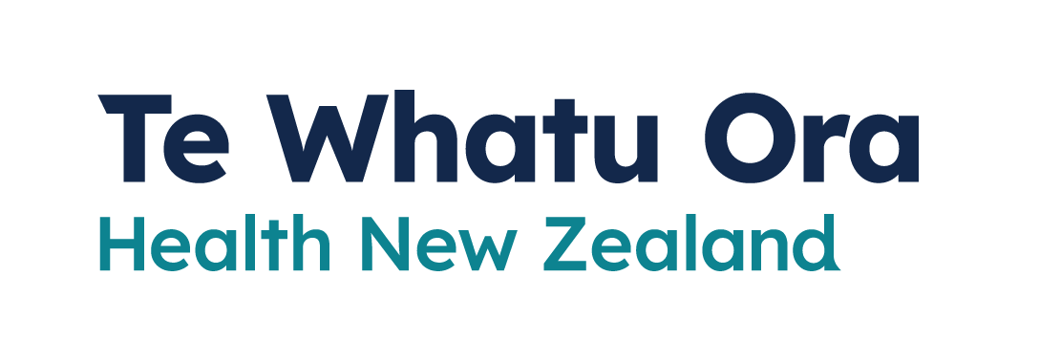
How to report your Rapid Antigen Test Results
Adapted in 2023 by Accessible Formats Service,
Blind Low Vision NZ, Auckland
TN: There are two logos at the top of the page. On the left is: Te Kāwanatanga o Aotearoa New Zealand Government. On the right is: Te Whatu Ora
Health New Zealand.

How to report your
Rapid Antigen Test Results
You should report the results of your rapid antigen test (RAT) if you test positive or negative. You can do this online through My Covid Record or by calling the helpline on 0800 222 478 and selecting option 3.

Reporting results in My Covid Record
Anyone in New Zealand aged 12 or over can sign up for My Covid Record.
First, you will need to create a My Health Account, which allows you to access your health information online. You will need your own email address to create an account.
For information about how to create a My Health Account take one of these two links:
- My Health Account | Ministry of Health (identity.health.nz)
- https://identity.health.nz/
You will find further information here at My Covid Record: Proof of vaccination status | Ministry of Health NZ or at this link https://tinyurl.com/5avpk2sy

Once you have an account, you can upload your results:
1. Log in to My Covid Record | mycovidrecord.health.nz (https://mycovidrecord.health.nz)
2. Under "Self-report a Rapid Antigen Test (RAT) result", tap or select "Report a test result".
3. Read the information provided and tick the box if you agree with the privacy statement. Tap or select "Continue".
4. Enter your mobile number, and tick the box if you consent to receiving COVID-19 information. Tap or select "Continue".
5. Indicate which lines are visible on your test by selecting "Yes" or "No".
6. Tap or select "Enter result".
7. Confirm you want to record your result on your official health record by selecting "Yes, enter result".
8. Advice about what to do next will appear.
If you have entered the wrong result by mistake, you will have 20 minutes to remove it.

Get help using My Covid Record
If you do not have a unique email address, a valid ID, cannot confirm your identity, or need help with My Covid Record, contact the Ministry of Health team, 8am to 8pm, 7 days a week. It will help to have your NHI number ready.
Email: help@mycovidrecord.min.health.nz
Call: 0800 222 478

Reporting results over the phone
If you are having trouble using My Covid Record, you can report the results of your RAT over the phone by calling 0800 222 478 and choosing option 3.
Use this option if you are reporting a RAT result for a child under 12.
End of How to report your Rapid Antigen Test results

